PYRAMIDOLOGY: THE SECRET POWERS of PYRAMIDS & VASTU SHASTRA
The most famous Pyramid, the one that Pyramid Power is based on, is the Pyramid of Khufu (Cheops Pyramid). Khufu, also known to history by the Greek name of Cheops, was the second pharaoh of the 4th dynasty of Ancient Egypt during the Old Kingdom Period. The last remaining structure of the Wonders of the World, it stands ten miles West of Cairo, on a mile-square plateau which was leveled by slaves and is part of a three-Pyramid complex called the Gizeh. Pyramid of Khufu is the most mathematically perfect structure in the world.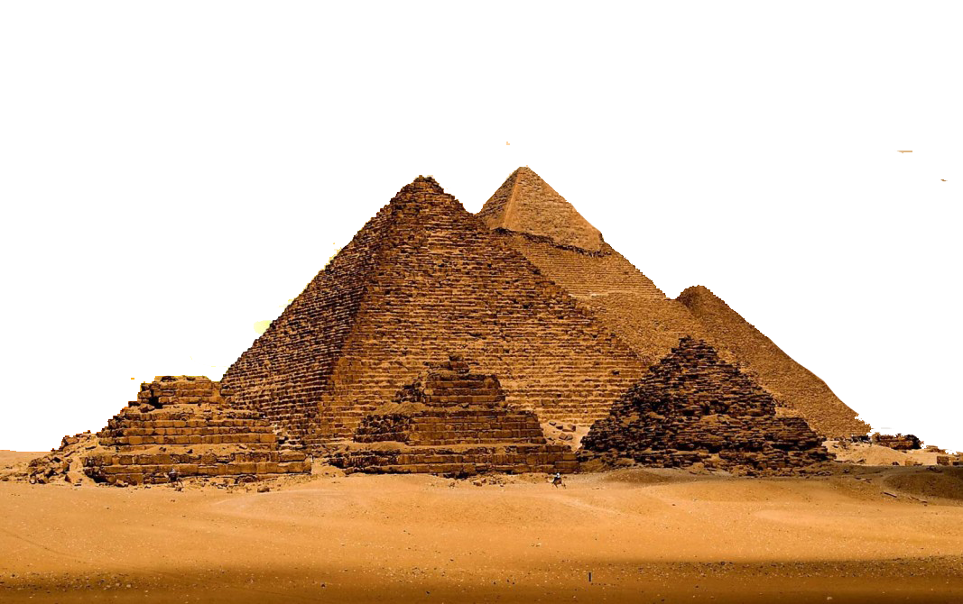

Pyramid power refers to the belief that the ancient Egyptian Pyramids and objects of similar shape can confer a variety of benefits. Among these assumed properties are the ability to preserve foods, sharpen or maintain the sharpness of razor blades, improve health, function "as a thought-form incubator", trigger sexual urges and cause other effects. Similar theories regarding Pyramids are collectively known as Pyramidology.
Some ancient civilizations believed that man was linked to the eternal universe by a vital force which filled the cosmos. In India, they call the energy ‘Prana’. Pyramid is reverberating to the Earth’s magnetic field and creates a life force energy or ‘Prana’. ‘Pyra’ word comes from the Greek lingua franca meaning fire and ‘Mid’ from the Latin word ‘Mede’ which means middle. Therefore, Pyramid is actually “Fire in the Middle”. Fire in the Middle is an apt description for the natural life energy force that is found in the center of the Pyramid.
Any geometrically symmetrical structure has more inherent energy than any asymmetrical structure and a Pyramid, being the most symmetrical of all structures, has the highest energy. This energy is useful for both material purposes as well as for spiritual purposes.
Pyramids are powerful objects, they create a massive single line energy in a vortex form. The vortex is a term for alignment to Universal Source of Energy (or whatever you call The Universe, God). Being in the vortex means you are in vibrational alignment to your desires. It’s represented by feelings like enthusiasm, inspiration, passion, joy, and appreciation. Being out of the vortex means you’re energetically kinked, not letting in the good stuff you’ve been calling in. It often feels frustrated, hopeless, fearful, or angry.
It is symbolically believed that the Pyramids are ante types of the ‘Holy Mountain’ or the ‘High Place of God’. The square base means that the Pyramid or ‘House of Wisdom’ is solidly founded on Nature and its Immutable Laws. The Pyramid Angles represent Silence, Profundity, Intelligence and Truth. The South-side of the Pyramid signifies Heat, the North-side represents Cold, the West-side symbolizes Darkness and the East-side, Light. The Triangular Sides typify the three-fold Spiritual Power.

Pyramid Research and Scientific Recordings:
The Modern Concept of PYRAMID VASTU has a more Scientific Approach. In recent years, “Pyramidology” has experienced a great resurgence in popularity. Pyramid Power has become the primary focus of everything from veterinarian concerns to extraterrestrial messages. Research done in Pyramid Environment show amazing results that can be applied scientifically for enhanced benefit to mankind and nature.

An international research group has applied methods of theoretical physics to investigate the electromagnetic response of the Great Pyramid to radio waves. Scientists predicted that under resonance conditions, the Pyramid can concentrate electromagnetic energy in its internal chambers and under the base. The research group plans to use these theoretical results to design nanoparticles capable of reproducing similar effects in the optical range. Such nanoparticles may be used, for example, to develop sensors and highly efficient solar cells. The study was published in the Journal of Applied Physics. (Propagation of electromagnetic waves inside the Pyramids of Cheops, ITMO University, Laser Zentrum, Hannover)

The science of torsion fields goes well beyond an explanation of extrasensory perception. For example, the Earth is always sending and receiving 'torsion fields', as does any physical object by virtue of its ‘breathing'. However, the fields of larger objects such as the Earth, the Sun, or the center of the galaxy are a lot stronger than smaller objects due to their sizes. The easiest low-tech way to harness these energy fields is to build a Pyramid or other cone-shaped structure. Since all physical matter absorbs and releases ' torsion fields ' in this new model, one can capture and direct these waves by building the right type of structure.
A lot of work has been done with individuals who meditate. The theta and alpha brain waves are increased. These frequencies are also higher, and the signal strength is twice the 9amplitude of normal. Dr. Carl Benedicks (a Swedish scientist) discovered that the Pyramid produced a resonance or frequency inside it. Two German scientists, Born and Lertes, also discovered that this frequency was in the microwave range. Researchers discovered that items placed under a Pyramid stay "charged" for various lengths of time after being taken from under the Pyramid. Crystals and water keep their "charge" longer than anything else.
Therapeutic Effect of Pyramids in Medical Field:

* Prof. S.M. Kilmenko and D.N. Nosik, M.D., from the Ivanovskii R & D Institute of Virology within the Russian Academy of Medical Science, conducted a study involving the drug Venoglobulin, a naturally occurring virus-fighting compound in human beings. They found that when the drug was diluted into a concentration of 50 micrograms per milliliter and stored in the Pyramid for a time, it became approximately three times more effective at fighting viruses.
* Prof. A.G. Antonov et, from the Russian R & D Institute of Pediatrics, Obstetrics and Gynecology, tested the effects of a solution of 40% glucose in distilled water after it had been stored in the Pyramid. By administering only one milliliter of the glucose to twenty different prematurely born infant patients with compromised immune systems, their levels of health were seen to rapidly increase up to practically normal values. The researchers, furthermore, discovered that the same effect could be produced by simply using one milliliter of ordinary water that had been stored in the Pyramid.
*Doctors have been experimenting with Pyramids. A Canadian hospital tried using a Pyramid in their burn ward. The results were that after being under the Pyramid for a few minutes, the patients' pain started to reduce. They also found that burns areas healed much faster.
* Standard solutions such as glucose and iso-osmotic solution become effective for treating alcoholism and drug addiction after being placed in the Pyramid. They can be administered either intravenously or outwardly.
* More importantly, these studies give extremely convincing evidence that the DNA molecule is directly affected by outside energy sources. If the DNA molecule is assembled by an unseen source of energy, then when we increase the flow of that energy into the DNA, we can also expect that the health and vitality of the organism will increase.
* Bill Kerell, a Pyramid researcher, has been told by a doctor from a Canadian hospital that they tried using a Pyramid in their burn ward. The results were that after being under the Pyramid for a few minutes, the patients' pain started to go away. They also found that the burn areas healed much faster.
* Stimulation of Psychic Power: Extra Sensory Perception (ESP) laboratory, a psychic research organization based in Los Angeles, California, USA, is conducting experiments in which the Pyramid shape is used as an incubator for thought forms. The Pyramid forms a geometric amplifier which increases the power of prayers or strengthens the spiritual requests of a religious devotee. Members of worldwide organizations are ostensibly experiencing ‘outstanding successes’ in this use of Pyramid form.
* Resonance in Pyramids: Dr. Carl Benedicks a Swedish scientist, discovered that the Pyramid produced a resonance or frequency inside. Two German scientists, Born and Lertes, also discovered that this frequency was in the microwave range.
Natural Oil:
* A series of Pyramids were built over several oil wells. It was discovered that the viscosity of the oil under the Pyramids decreased by 30%, while the production rate accordingly increased by 30% compared to the surrounding wells. There was a decrease in the amount of unwanted materials in the oil, such as gums, pyrobitumen, and paraffin. These results were confirmed by the Gubkin Moscow Academy of Oil and Gas.

Pyramids and Plants:
* Seeds were kept in a Pyramid for one to five days before being planted. More than twenty different seed varieties were planted across tens of thousands of hectares. In all cases, the seeds from the Pyramid had a 20 to 100% increase in their yield; the plants did not get sick and were not affected by droughts. Plants grown under the Pyramid grow about twice as fast, in their early life, then do plants that are not grown under it. The treated young plants look healthier and have less insect damage.

Animals:
* Bill Kerell a dedicated Pyramid researcher for 17 years, has done many experiments using brine shrimp. Brine shrimp usually live six to seven weeks; but under the Pyramids, Bill kept them alive for over a year. He also noticed that Pyramid-grown shrimp grew two to three times larger than normal.
* One of the most interesting accounts of Pyramid power was cited by Serge King in his book, “Pyramid Energy Handbook”. In this book, King speaks of ways people can help their dogs, cats, fish and fowl. “One of the researchers recently reported that she placed a Pyramid over the cage of an excitable bird. The bird immediately flew to the top of the cage in an apparent attempt to get as close to the Pyramid as possible and has since remained far calmer than before”.
*Testimonials from several sources demonstrate that pets of all kinds thrive under, or within open-frame Pyramids. Dogs and cats are observed to respond to this unique form of energy environment in harmonious ways.
* Songbirds fed on Pyramid Water sing better.

Food:
* Food kept under the Pyramid will stay fresh for two to three times longer than uncovered food. Artificial flavorings in food will lose their taste, but natural flavors are enhanced. The taste of foods change; they become less bitter and acidic. When we take a spectrographic reading of the treated item, it will show a change in the molecular structure. The Pyramid will dehydrate and mummify things, but it will not permit decay or mold to grow. There is also a slowing or complete stopping of the growth of microorganisms.
* Pyramid-charged foods can make people more loving. A quantity of salt and pepper was stored inside the Pyramid by Russian research teams. This salt and pepper were later removed and fed to about five thousand people in different selected jails in Russia. Amazingly, within a few months there was a dramatic improvement in their behavior, and most criminal behavior almost completely disappeared, whereas the ‘control’ jails showed no signs of behavioral change. Nothing in the jails under study had changed except that this salt and pepper was secretly added to their food. This study regarding the prisoners is one of the most important points, as it validates the idea that Aetheric energy (a name given by neo-Theosophy to a vital body or subtle body) is ‘spiritual energy’, and that as a person is exposed to higher intensities of it, there is a propensity for greater feelings of love and compassion for others. Hence, if we can make a strong case that we are moving into a more highly charged area of torsion-wave energy, then we can also assume that our civilization will exhibit some very positive changes.

Water:
* It has been found by many people that keeping drinking water in Pyramids, fills it with the negative ions. These ions produced by the Pyramid energy are very beneficial for us. If one keeps water under a Pyramid overnight and drinks it later, it is more useful.
* It has been found that water keeps its "charge" longer than anything else. When the water is being charged, it is the oxygen molecule that is being charged since the oxygen molecule is the element in the water that forms the 'octahedron crystal'. The oxygen vectors realign themselves when under a Pyramid. Water will lose its chlorine taste and generally tastes better. Drinking Pyramid Water has been reported to have beneficial and curative results. People and pets drinking Pyramid water allegedly feed and look better.
* Plastic bottles of distilled water were kept in the Pyramid for three winter months where the air temperature sank to as low as -38 ͦC, or -6 ͦF. Thermometers inside the bottles revealed that the temperature of the water was equal to the air temperature, but the water remained in a liquid form and would not turn into ice. However, if the water in any of the bottles was shaken or bumped in any way, it would immediately start crystallizing and quickly turn into a block of ice. Golod and his associates have videotaped these results.
* Soaking arthritic joints in Pyramid Water relieves and, in some cases, eliminates the related pain and problems.
* Applying Pyramid Water to cuts, burns, bruises, moles, calluses, hangnails, warts etc., appears to be of definite help in their cure along with normal medication used for treatment.
* Food cooked in Pyramid Water develops better taste and quality.

Weather:
* Studies in Russia show that the atmosphere surrounding a Pyramid seems to be shielded from severe weather, causing an overall decrease in the amount of violent weather patterns, which are deflected around the area where the Pyramid is located.

Human Experiences in Pyramids:
* Kirlian photographs of human subjects show the aura to be significantly brighter after a 15-minute exposure with the Pyramid.
* Bill Kerell and his associates have found that hypertensive individuals become tranquilized, but lethargic people become energetic again.
*Researchers have been able to show that there is a helical vortex of energy emanating from the apex of the Pyramid which expands in diameter as it rises higher and higher.
*Persons living inside of a Pyramid home, working within a Pyramid building or those who meditate within, or sleep under, a Pyramid framework generally feel positive, immediate reactions. Reports sometimes include temporary, energy nausea apparently due to excess body toxins.
* In research work with individuals who meditate in a Pyramid, it has been found that the theta and alpha brain waves are increased. These frequencies are also higher, and the signal strength is twice the amplitude of normal brain waves.

MEDITATION and PYRAMIDS:
When Pyramids worn as a hat, have a strong ionization effect within the body. Here how it works: Negative ions enhance the oxygen intake of the human body and through that, strengthen, concentration and capacity of the human being activates. The endocrine glands of the body are activated through the vibration of the electrical precursing/forerunning field of Pyramids. This balances the precursing energy field around the endocrine glands and makes expanded consciousness.

Pineal Gland & Pyramid Energy
The pineal gland, or third eye, is in the geometric center of the brain. This correlates to the location of the Great Pyramid in the center of the physical planet. It is the center to produce the hormone melatonin. Melatonin is implicated in a wide range of human activities. It regulates daily body rhythms, most notably the day/night cycle (circadian rhythms). Environmental stresses affect pineal function, impacting overall body alertness, temperature levels, and hormone operation. Stresses that affect pineal function include unusual light and dark rhythms, radiation, magnetic fields, nutritional imbalances, temperature swings, high altitude, and overall daily stress patterns. Pyramid is a cosmic antenna. It flows three times more cosmic energy. Head Pyramids help to reduce the level of stress and tension in the physical body. A Pyramid energy puts a mind into a theta-alpha state. It helps raise your vibration with a head meditation Pyramid, a perfect light tool.

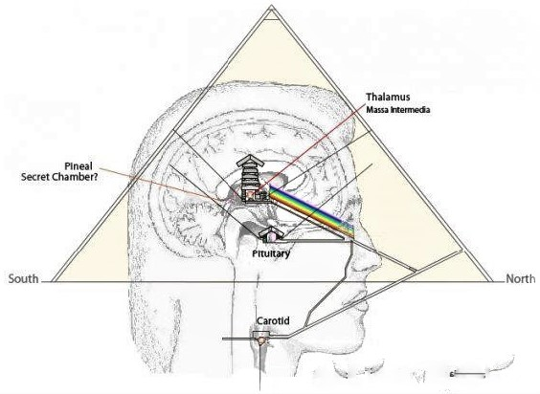

Careful study reveals several unique and beneficial qualities that may be derived from Pyramid Meditation. Experienced Meditators relate profound results in their quest for expanded awareness. Many people feel that psychic powers are stimulated or heighten using Pyramids.
Psychics who use Pyramids in that fashion have achieved an altered state of consciousness more rapidly than they would have otherwise, placed on the head focusing through the ‘chakra’ system, during Meditation sessions, clearing psychic passages which may have become blocked. The Pyramid is a geometric amplifier which increases the power of prayer or strengthens the spiritual request of a religious devotee. Pyramid Meditators suggest that the best results are achieved by sitting upright with the upper chakras located approximately one third up from the Pyramid base directly under the apex.
The use of a Pyramid in meditation can accelerate the process bringing feelings of calmness, wellbeing and a more open and positive attitude. Many users claim increased memory recall, visions of past incarnations, telepathic communication and an expansion of awareness.
Verbal and written testimonials, among experienced and non-experienced Pyramid meditators throughout the world have reported that the Pyramid shows the following reactions.
- A sense of weightlessness.
- A tingling sensation on the skin, like that of mild electricity.
- Feelings of warmness, usually in the upper portions of the body.
- Tranquility, relaxation and freedom from tensions. A tranquilizing effect on the nervous system.
- A deeper “dropping off” in the transcendental state and very graphic dreams in vivid color.
- External stimuli, sight and sounds particularly fade away.
- A Space consciousness prevails including time distortion, both of speed and slowing down.
- Deeper, more fulfilling meditations and higher energy levels.

Evidence from Ancient Egyptian Tombs:
Egyptologists have found well preserved grain in tombs that is thousands of years old. In sharp contrast, grains stored in modern silos usually spoils after only a few seasons of storage. Grain in modern silos (a silo is a structure for storing bulk materials) usually keeps no longer than four years.
Modern concept of Pyramid Power was further strengthened by a Frenchman named Antoine Bovis in the 1930s. While he was exploring the Cheops Pyramid, he entered the King's Chamber. He noticed there were garbage cans scattered around the room containing cats and other small animals which had gotten lost in the Pyramid and died. Although the room was extremely hot and humid, Bovis realized the dead animals had no odor. They had not decayed. They had mummified.
Bovis was fascinated by his discovery. He returned to France and experimented, constructing a scale model of the Cheops Pyramid about two and a half feet tall. He set it precisely on a North-South axis, just as the original had been aligned. At the point of the King's Chamber, one-third from the base of the Pyramid, Bovis put a dead cat. After a while, it mummified. Excited by his results, he stepped up his experimenting using fish, calves’ brains, and other organic matter with a very high decay rate. They, too, dehydrated and mummified.
The preservation of organic material in Pyramids has received a lot of attention in popular books. Bovis's observation gave rise to the idea of 'Pyramid power,' which preserve organic matter. Advocates of Pyramid power include a French radiologist named Jean Martial; electronics engineer from Prague named Karl Drebal; author and biologist Lyall Watson; and physicist Patrick Flanagan. Karel Drebal, interested in parapsychology, read of Bovis' experiments. He was busy doing mummification experiments when, one day, he was reminded of an old army trick: place a straight edged razor on the window sill at night in the light of a full moon and the next morning the blade will be totally dull. According to Drebal, "The polarized light of the moon has an unfavorable effect on the sharpness of the blade because polarized light vibrates in one direction only." Drebal wondered if the shape of the Pyramid could act as an energy accumulator for all the electromagnetic rays around us.
Small models made of paper, wood or other materials, have been tested for desiccating organic matter and sharpening razor blades. Several tests have demonstrated Pyramid to be capable of preserving organic matter.
At Saqqara, Egypt, Egyptologists excavated a tomb of a woman of lesser nobility. In accordance with funerary customs, an elaborate meal was set out on pottery platters. The meal consisted of porridge, quail, kidneys, pigeon, fish, beef ribs, triangular loaves of bread, cakes and fruits. Their state of preservation was so excellent that Egyptologists easily recognized all the foods in the entire meal, although it is almost 4,500 years old. The example suggests that shape is the key to the phenomenon popularly known as ' Pyramid power’.

Interesting Information on Pyramids:
* Decoration on Pyramid Sides: Symbols decorating a Pyramid's sides produce a positive result and variety of positive responses.
* Edgar Cayce, one of the world’s greatest psychics, said in one of his readings that the Pyramids of Giza were not built for purposes of entombment, but as storage places for the history of humankind from the very beginning up to the year 1998. This history is written in the languages of mathematics, geometry and astronomy.
* Manly P Hall, an expert on religious practices hypothesizes Pyramid Research and Scientific Recordings in his book “The Secret Teachings of All Ages” that Pyramids were built by survivors of Atlantis, the lost continent. According to Hall, the Pyramids remain as the visible covenant between eternal wisdom and the physical.

The Science behind Pyramids:
All Pyramids, whether they are in Egypt or elsewhere on the planet Earth, aligned to the magnetic North, which amplifies their energy. This energy is life force source energy, which surrounds all life form when active. Pyramid attracts positive etheric energy and converts the negative into positive ions.
The science behind this ancient structure is truly fascinating. When constructed, the Pyramids are generally in direct line with the true North and South (and not magnetic North or South) directions. True North or South is a constant and refers to the geographic North or South Pole. There are energies or electromagnetic field that run in this direction and encompass the Earth. And the reason it is not magnetic North, is that our Earth sits on a tilt-rotating orbit. It is not perpendicular to its orbit going around the Sun. Our Earth is slanted or tilted at an angle of 23.5 degrees from its orbital plane. This tilt is not only responsible for the changing seasons as the Earth revolves around the Sun but also for a very special energy force that comes into play as the Earth rotates around itself. And when the Pyramids are aligned to the true North, they pick up direct energy belts and energy fields that keep the planet in its orbital spin.
When we spin anything, it creates a centrifugal motion. The faster it spins, greater the centrifugal force. The centrifugal motion is also an integral aspect of electricity, so it is a form of energy. In this way, when Pyramids are aligned to the true North, they pick up the centrifugal-force-energy which is a higher energy. It captivates the energy and bounces it from equal sides of its walls and collects it in the center in a rotating effect. The energy that collects inside has no magnetic proportions. It is completely free of any magnetic force, it is a sovereign energy. When objects are placed in a Pyramid, the energy inside immobilizes the object in its aging process or puts it in a sort of vacuum system. This allows whatever is put there to stay there in that form for a long time, like the way the Earth is in the Sun's orbit for ages.

In general, Pyramids are good conductors of electricity. It means, they can transfer information better than others. When an object is placed inside the Pyramid, it receives amplified or stronger information about itself. This frequency raises the potential of the elements and "charges” them. This is irrespective of what is put into it. For example, if one puts razor blades under a Pyramid, it will stay sharp because the information that makes up those microscopic metal crystals try to remain in their original shape by trying to move atoms to the areas that were worn away. Similarly, if one is trying to meditate under a Pyramid, the person's efforts are amplified, and he can reach the 'thought free' state faster under it. It is also a known fact that one should not think of negative things inside a Pyramid as they too will get amplified. Pyramids do not distinguish between things put under or inside it by itself but only amplifies whatever is there.

When it is built of stone, which is a soluble mass, or wood, or of anything that is not a conduit, then the Pyramid is able to collect the energy within to utilize it for whatever is put inside. And if we choose to put ourselves in there for meditation, we will experience the magic of 'thought-free' state faster than ever before!

A large volume of magnetic concentration exists within the Pyramidal boundaries which helps protect the human body from adverse effects of negative energies and radio frequencies. With regular use, the Pyramid will help to create a beneficial environment for your body to function properly.

The shape of Pyramid is like the Carbon Atom which is one of the Base Structures of Creation. The Carbon Atom is a tetrahedron and has the inherent characteristic that when aligned to magnetic North is rings and sings. The Pyramid shape acts like a lens and focuses the Earth’s magnetism.

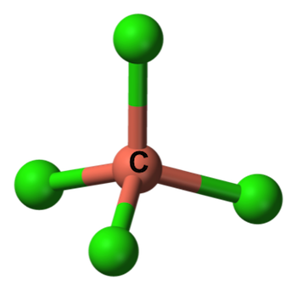
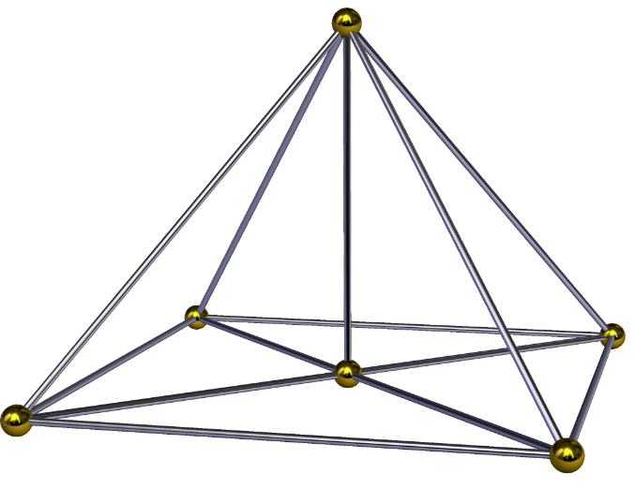

CARBON ATOM PYRAMID SHAPE

How a Pyramid Works?
Negative ions help to reproduce and repair body cells. They're transmitted into the body through the air and are circulated by the blood. Too many positive ions (the result of air pollution equivalent to oxidation) can cause depression, and ultimately, illnesses. Thus, negative ions have a beneficial effect on the body.
Pyramids generate negative ions. In addition, they are believed to have a generally balancing effect on the body's electromagnetic field. This effect is greatly enhanced if the materials used, is gold or copper.
Some experiments using properly oriented model Pyramids, built of a variety of materials and oriented to the Earth's North-South axis, have preserved organic matter.
Food kept under a Pyramid will stay fresh for two to three times longer than uncovered food. Artificial flavorings in food will lose their taste, but natural flavors are enhanced.
The taste of foods change; they become less bitter or acid. Spectrographic reading of the treated item will show a change in the molecular structure.
The Pyramid will dehydrate and mummify things, without decay or mold growing. There is also a slowing or complete stopping of the growth of micro-organisms.
Kirlian photographs show the aura to be significantly brighter after a 15-minute exposure period.

Reactions to Pyramid Environments:
Persons living, meditate, work or sleep inside of a Pyramid building or under a Pyramid framework, generally feel immediate positive reactions. Creatures are magnetically attracted to Pyramid replicas.
Testimonials from several sources, demonstrate that pets of all kinds thrive under, or within open frame Pyramids. Dogs and cats are observed to respond to the Pyramids.

SOME EFFECTS OF PYRAMID-ENERGY:
- Increased Effectiveness: Glucose and some iso-osmotic liquids stored in Pyramid are found to be more effective in drug de-addiction campaigns. They can be injected into the veins or given orally.
- Less Stress: Studies show that meditation relaxes your muscles and declutters your mind. The result using a Head Meditation Pyramid is total mind and body rejuvenation, and increased immunity to stress and pressures of everyday life.
- Better Sleep: You’ll experience refreshing, rejuvenating deep sleep. With this one simple change in your daily life, you’ll see immediate results.
- Increased Creativity: Amplify your ability to tap into ideas and create new ones. By connecting thoughts from both your conscious and subconscious mind, Pyramid energy will help you unlock new ideas easier than ever before.
- Sharper Focus: Effortlessly achieve laser-sharp focus and develop a goal-oriented mindset. In this state of mind, you can accomplish all your daily tasks in less time.
- Healthier Mind & Body: Meditation with a Head Pyramid has a powerful impact on every aspect of a person, from lowering blood pressure, to strengthening the immune system.
- Quick Healing: Pyramids helps and enhances speedy recovery from various diseases when combined with regular medical advice and medication.
- Healthier Water: if we drink water stored in a Pyramid shaped vessel for minimum three days, the universal energy will reach all parts of the body.
- Memory Power: If students wear Pyramid shaped caps while studying, their memory power and knowledge improves.
- Uniform Distribution of Energy: There is a continuous flow of energy in a Pyramid. Irrespective of the number of people present, everyone receives equal energy from the Pyramid.
- Reduction in Negative Thoughts: The will power increases inside a Pyramid. Hence, we should avoid negative thoughts while sitting there to avoid increasing the negative energy.
- Increased Productivity: If some seeds are kept in Pyramid for 1-5 days before their sowing, the yield from these seeds is found to be 20-100% more than the yield of normal seeds. The plants grown out of the seeds taken from Pyramid are found to be healthier.

USES OF PYRAMIDS:
* Charging Crystals is a popular use with Pyramids. Quartz crystals are most effective for that, as they hold the charge for several weeks. These crystals can then be used for healing purpose as they release their charge into the surrounding.
* Large Pyramids (the kind you sit inside) are often used for meditation, massage, acupuncture, and Reiki.
* Many people have also experienced that after sleeping inside a Pyramid they find that they need less sleep and feel more relaxed and at peace when they wake up.
* Many people put their drinking water in Pyramids to charge it with the Pyramid's negative ions.
It is recommended to put a glass inside a Pyramid for about half-an-hour, and large quantities overnight.
* The Pyramid activates the energies of the pineal and pituitary glands Users experience balance, relaxation, tranquility, well-being, and in some instances, the reduction of headaches.

PYRAMID VASTU:
Pyramid has been associated with Egyptian civilization and similar shapes are seen in many religious buildings like Temples, Churches etc. Its powerful tool used by Vastu Experts to enhance attributes of different Vastu Zones. It's should be used with a lot of precautions and only when you are sure about exact location of zones and zones are balanced according to the Principles of Vastu Shastra. Pyramids are such energized instruments which have their own powers and are not charged by some tricks, but Pyramids are organically charged. They keep the negative energies at bay from a place by absorbing all and neutralize the place. The incorrect Vastu of any place can make a home devoid of prosperity and contentment. Therefore, it becomes important to neutralize the energies with the proper placements of different Pyramid shapes.

Vastu is both a welfare science and a creative art of turning non-manifest energy into manifest material forms. At the core of Vastu is the science of energy and matter. Quantum physics tells us that anything having a mass has an equivalent amount of energy and vice versa. Einstein stated simply that E=mc2.
This simply means that any ordinary object with a modest amount of mass has a large amount of energy intrinsically. Vastu shastra is basically an integrated science that combines the Energy of Universe/Cosmic Energy and knowledge of science. Energy is the one, but it has different forms. The forms are nothing but the medium through the energy gets transformed. Vastu Shastra helps to get right form of energy to your dwelling.

The aim of Vastu is to establish a synergy between the inhabitants, the structure, nature and the universe. If the stored energy in any building is negative, the inhabitants suffer ill health, financial problems, unhappiness etc. If the stored energy in a building is positive, the inhabitants enjoy good health, wealth and happiness.

Whether there is an imbalance of energy or in other words any place needs extra energy, or the lack of energy may tend to prove harmful. Energy can neither be created nor destroyed. It can be transformed from one form to another. So, our home, office, industry etc. should have proper balance of essential energy failing which we may face problems associated with health, finance, prosperity etc. Bio-energy is the essential energy which should be present in our dwellings. But how can we calculate such energy? What quantity is needed and how to compensate the lacking energy? Answer to all these questions is Pyramid. Pyramid has got the ample power to compensate this lacking energy. A Vastu Expert can assess it with cause and effect symptoms experienced by the inhabitants of the premises.

Pyramid means inherent energy. It is believed that the angle, size and proportion of the Pyramids have the tendency to generate maximum energy within and around itself. It has the capacity to transform negative field into positive. Any energy can transform from one form to another but for this transformation, a transformer or generator is required. In case of bio energy, Pyramid acts as a generator. Pyramid has got the power to transform the incoming negative energy into positive one. It can even create an energy field in its surroundings. Lots of examples have shown this power of Pyramid as already discussed above. Pyramid can be used in the correction of several Vastu Faults or ‘Vastu Doshas’.

For example, if the level of Northeast is higher than Southwest, you may face severe financial problems. If correction through natural process is not possible, Pyramid can be of great use. In such case, appropriate energy can be created using adequate Pyramid in proper place. If the plot is cut from any side, and correction through traditional method is not possible, Pyramid can be installed in such cases to rectify the faults. Pyramid can create virtual boundaries and thus help in such cases.

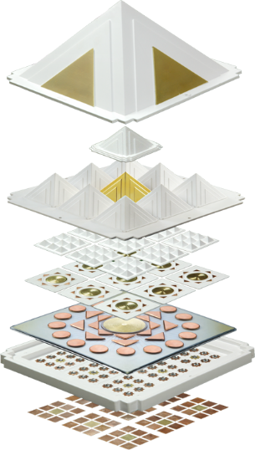

Multiple Pyramid Tool used for Vastu Shastra Energy Balance

DIFFERENT USES OF PYRAMIDS IN VASTU SHATRA:

- It can create Virtual walls i.e. an imaginary wall which cannot be seen but works like a wall. This is useful where the shape of the plots must be corrected without sacrificing any area.
- Pyramid can create virtual energy. If the slope of any plot is not correct and it is not possible to correct it traditionally, Pyramid is very helpful in such cases. Appropriate number of Pyramid should be installed in right place to create energy.
- Pyramid can be used in balancing the energy level of complete property.
- To rectify the bore well in wrong place.
- To rectify the location of overhead water tank without moving it.
- Bringing harmony in relationships especially among couples.
- It can be used in automobiles for better performance.
- Pyramid is very helpful in enhancing performance in job, business etc.
- For better results in studies and career.
- For business growth.
- It can also be used in financial growth.
- Pyramid is very useful in healing many health problems.
- To enhance memory power.

There are different types of Pyramid manufactured with different material. The size and material of Pyramid decides the energy creation capacity. Pyramids should be used with prior advice of an expert as it could have negative impact also if not installed properly when placed at negative energy zones.

The use of Pyramid in Vastu is now very popular and there are different patterns of Pyramid available in the market. But these products are of no use as they are not energized and programmed. If you have a laptop or desktop and no software is installed in it then will you be able to run any program on it? No. Any computer needs command and programming to run. Similarly, Pyramid can be made easily but it is useless unless it is programmed. Programming in Pyramid is done by keeping it in highly energized Pyramid field for fixed duration by Vastu Experts only. The level of energy put into Pyramid is different for different purposes.

Some References for further readings are:
Pyramid power From Wikipedia, the free encyclopedia
The Reincarnation of Edgar Cayce by Wynn Free David Wilcock
Anke Petersson’s Spiritual Reality and Pyramid Power
Ami Roach in Extraterrestrial (Fact or Fiction; Science Fiction; Religion)
Pyramid Power by Max Toth and Greg Nielsen

Disclaimer:
Any data, interpretation, prediction or information in any form received through this blog should not be treated as substitute for advice or treatment you would normally receive from medical professionals, financial advisors, legal consultants and other such licensed services. The blog is purely for the informational/educational purposes only. The views expressed in this blog shall not be read as libel and/or defamation and are not intended to harm or malign feelings for any religion, club, society, organization, and/or company or anyone in anyway whatsoever.

